Pre-Requisites
- Client subscription with SharePoint 365 licensing.
- Fileserver credentials with full access to all client data.
- A server or workstation located on-premises to be used as a SharePoint migration agent.

SharePoint Configuration
- Login to the client Microsoft SharePoint 365 Administrator portal.
- Navigate to Sites > Active Sites.
- Press the Create button.
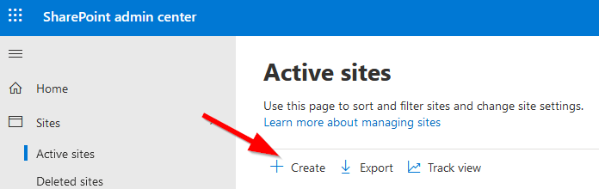
- At the Create a site prompt, select Team site.
- Fill in the Site name, and select a site Primary administrator.
- Enter an account you would like to use in the Group owner field.
- Expand Advanced settings and select the proper time zone.
- Enter any pertinent information into the Site description field, then press the Next button.
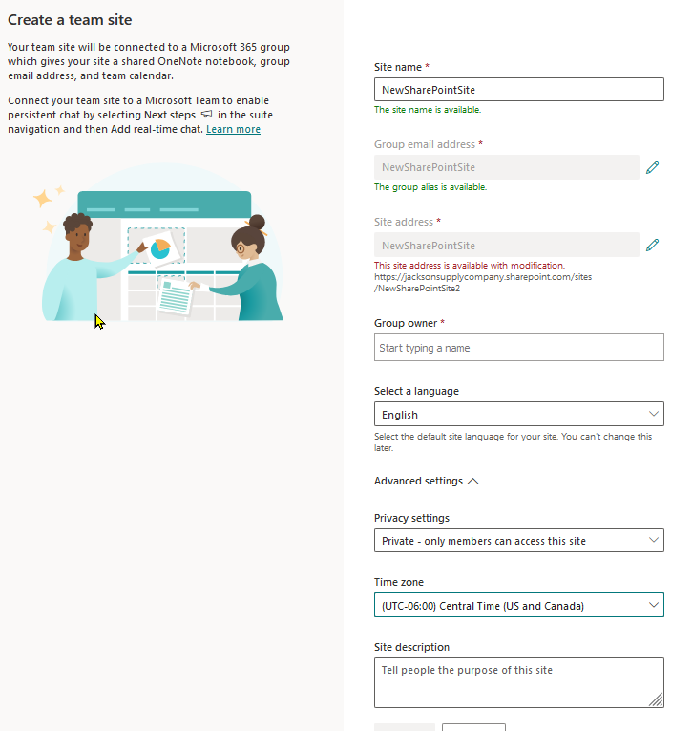
- Enter this SharePoint site users or groups on the Add site owners and members page.
- Press Finish.
- Your site is now being built; It may take 10-15 minutes for the site to be completed.
- Once the site is created, record its URL from the Active sites pane (it will be needed later).

SharePoint Site Share Prep
- Login to the client Microsoft SharePoint 365 Administrator portal.
- Navigate to Sites > Active sites.
- Find the new SharePoint site created in the Active sites list and select it.
- In the popup to the right, click on the URL link.
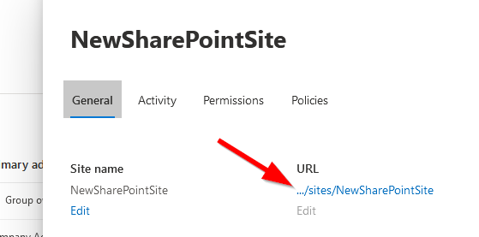
- You should now be looking at your newly created SharePoint site.
- Click on the New button and select Document library from the drop-down
  - You will want to create a new Document library for each share you will be migrating to SharePoint.
  - You can house all shares inside one document library, however, separate libraries have worked better for our clients.
- Enter a name that matches your share in the Create document library popup to the right.
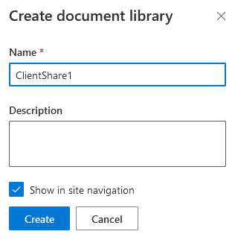
- Make sure the Show in the site navigation box is checked, then press the Create button.
- Once the share is created and is now visible on the SharePoint site homepage, click on the Home button at the top left-hand side of the screen.
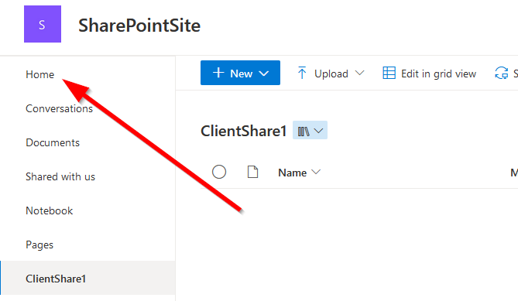
- Execute steps 5 through 9 for all shares you will be migrating to SharePoint.
- There are many customizations that can be applied to SharePoint sites; however, we are focusing on the migration aspect in this document only
- Once finished, you are now ready to continue to the next section.

Migration Agent Installation
- Login to the client Microsoft SharePoint 365 Administrator portal
- Navigate to Migration.
- Click on View tasks under File shares.
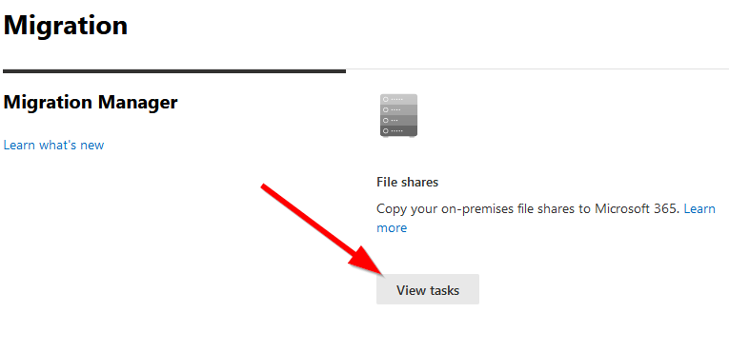
- On the file share migration page, select the Agents header and click on the Add button.
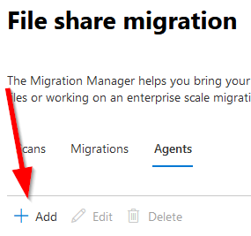
- An Add agent box will pop-up, click the Download agent setup file.

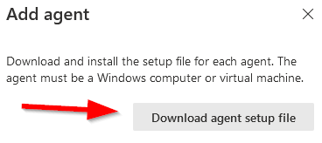
- An agentsetup.exe file will download.
- Run the agentsetup.exe installation application on a designated machine.
- The machine will be listed as an agent if the installation was successful.
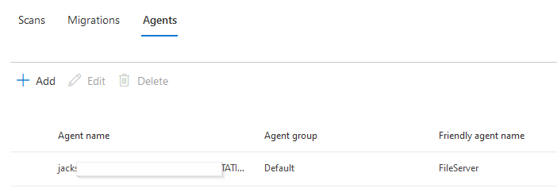

Migration Agent storage location adjustment if needed:
Special Note: After the agent has been installed on the computer, you may want to change the working directory. The default is in the user AppData folder on the C: drive. If the agent fills this drive with logs and caching information for the transfer, the workstation or server can slow down significantly or even crash during migration!
- Create a working directory on an alternate drive location with plenty of empty space.
- On the SPMT host computer, start SERVICES.MSC.
- Look for the program “SharePoint Migration Service” and stop the service.
- In file explorer, go to this folder: “C:\Users\username\AppData\Roaming\Microsoft\SPMigration\Configs”
  - Fill in username with the user name you used to register the migration tool.

- In this folder look for the “AGENT.CONFIG” file and open the file in a text editor.
- Find this line: "WorkingFolder": "E:\\MigrationLogs",
- Replace the working folder name with the folder you created in step 1.
  - Remember to use the \\ between folder levels not a single \ or the change will not work!
- Start the “SharePoint Migration Service” again.

Setup File Share Migration Job(s)
- In the SharePoint admin center, navigate to Migration > Migrations.
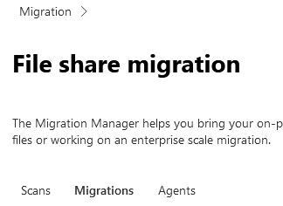
- Click on the Add Task button.
- Select Single source and destination and press Next.
- Enter the file share path into the Source field in the correct format.
  - \\serverFQDN\fileshare
- Click Next.
- Select SharePoint on the Select a Destination screen.
- Press Next.
- On the Select a SharePoint site destination screen, type in the URL saved during site creation.
- Select the location you want to copy your content selection will then appear right below.
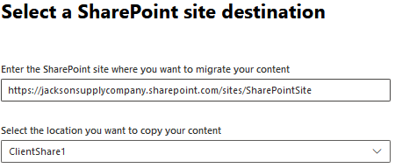
- Press Next.
- Give your task a Task name.
- Select Run now or Run later in the Task schedule.
- Select a specific agent in the Agent group assignment drop-down or leave the default.
- Your first pass should be a scan-only pass, so check the Perform scan-only box.
- The following settings should be selected for any migration task you assign to the migration project.
  - Checked boxes for the initial pass.
    - Perform scan only.
    - Preserve file share permissions.
    - Migrate hidden files.
    - Replace invalid file name character with (use _).
    - Azure Active Directory lookup.
  - Checked boxes for a migration pass.
    - Preserve file share permissions.
    - Migrate hidden files.
    - Replace the invalid file name character with (use _).
    - Azure Active Directory lookup.
- Click the Run button, once ready to proceed.
- Your newly created task will now appear in the Migrations list.
- Repeat steps 1 through 17 for each share you will be migrating to SharePoint.
- Once an initial Perform scan-only task has been successfully completed, you will want to select your task in the Migrations task list.
- In the task Details callout to the right, click on the Settings link and uncheck the Perform scan only box.
- This task is now ready to copy data to the SharePoint cloud.
- All tasks can be executed from the Migration > Migrations list by selecting the task(s) and clicking either the Run or Schedule buttons.
- Your jobs/tasks progress will be easily tracked in the Migrations list as well.
